Cardiac Diagnostic Services

EKG Entrance Examination - 2015

Technician Name: ______________________ Date: ________________ Score: _______________

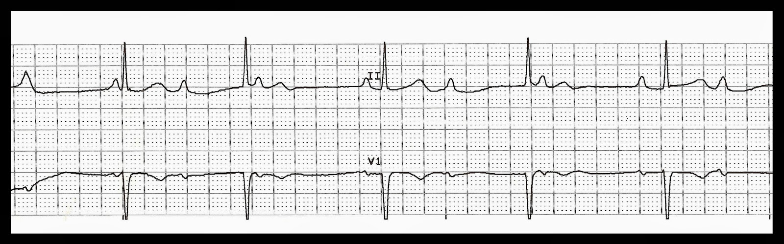

PR: __________ QRS: __________ QT: __________ HR: __________

Interpretation: __________________________________________________________________________________________________________________________________________________________________________

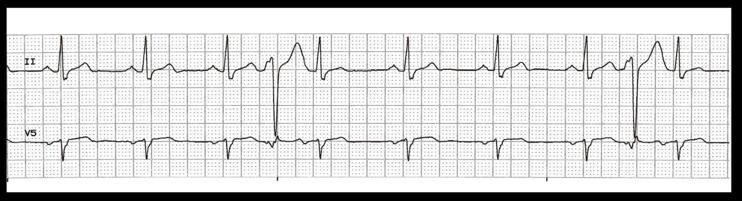

PR: __________ QRS: __________ QT: __________ HR: __________

Interpretation: __________________________________________________________________________________________________________________________________________________________________________

[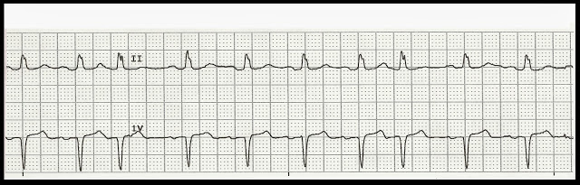](http://4.bp.blogspot.com/-SH9E4P1Csms/UkgasR7XU8I/AAAAAAAAV68/LK7fhyRh5G8/s1600/NSR+with+PACs+(2).jpg)

PR: __________ QRS: __________ QT: __________ HR: __________

Interpretation: __________________________________________________________________________________________________________________________________________________________________________

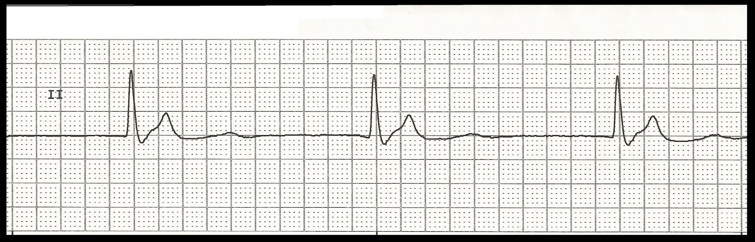

PR: __________ QRS: __________ QT: __________ HR: __________

Interpretation: __________________________________________________________________________________________________________________________________________________________________________

[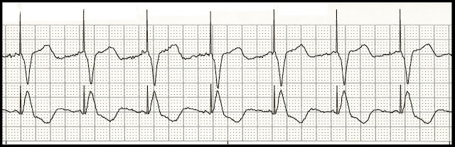](http://3.bp.blogspot.com/-cV6r49Jq7z8/UP2EIxe5_4I/AAAAAAAAPA0/RZUdYTCIUF8/s1600/1+b+Ventricular+paced.jpg)

PR: __________ QRS: __________ QT: __________ HR: __________

Interpretation: __________________________________________________________________________________________________________________________________________________________________________

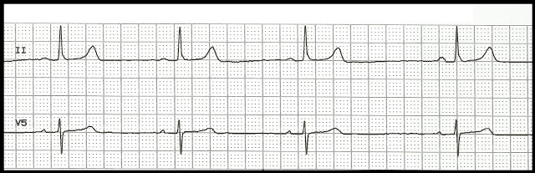

PR: __________ QRS: __________ QT: __________ HR: __________

Interpretation: __________________________________________________________________________________________________________________________________________________________________________

[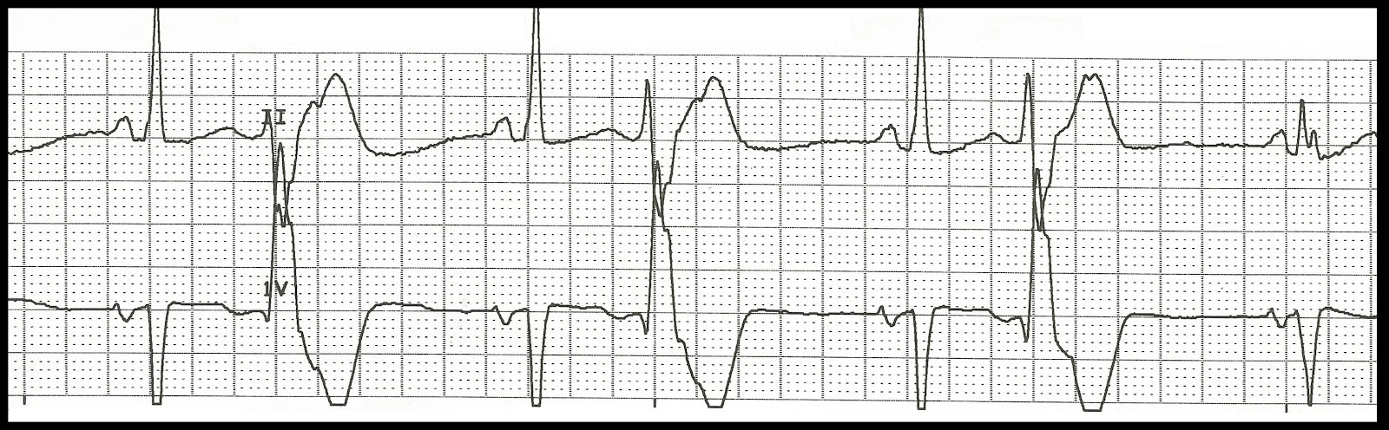](http://2.bp.blogspot.com/-gxdmyk7vLWw/UXJ3zxQQoLI/AAAAAAAASrg/hg59YuAV26A/s1600/Bigeminal+rhythm+with+a+fusion+beat.jpg)

PR: __________ QRS: __________ QT: __________ HR: __________

Interpretation: __________________________________________________________________________________________________________________________________________________________________________

[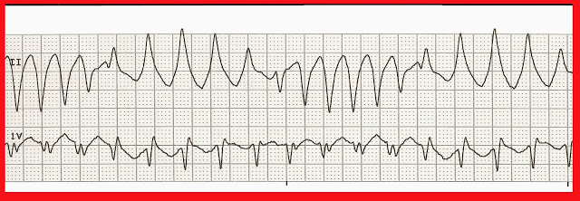](http://1.bp.blogspot.com/-pBB3WbnIvZ0/UpleKGwSoyI/AAAAAAAAXSY/EanQO6liBvk/s1600/29+Torsades+de+pointe+(2).jpg)

PR: __________ QRS: __________ QT: __________ HR: __________

Interpretation: __________________________________________________________________________________________________________________________________________________________________________

[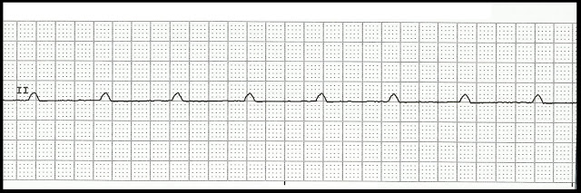](http://1.bp.blogspot.com/-fP3eXxMvhMs/UQAqumzOYnI/AAAAAAAAPkg/b9u6b8zn6qM/s1600/Ventricular+standstill+01.jpg)

PR: __________ QRS: __________ QT: __________ HR: __________

Interpretation: __________________________________________________________________________________________________________________________________________________________________________

[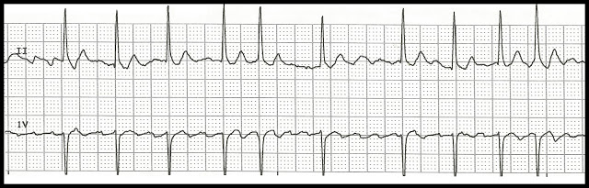](http://1.bp.blogspot.com/-Mz9Gs9810Fs/UdjbvlGkZbI/AAAAAAAAVDU/XDglVHc7Y6c/s1600/Atrial+fibrillation+05.jpg)

PR: __________ QRS: __________ QT: __________ HR: __________

Interpretation: __________________________________________________________________________________________________________________________________________________________________________

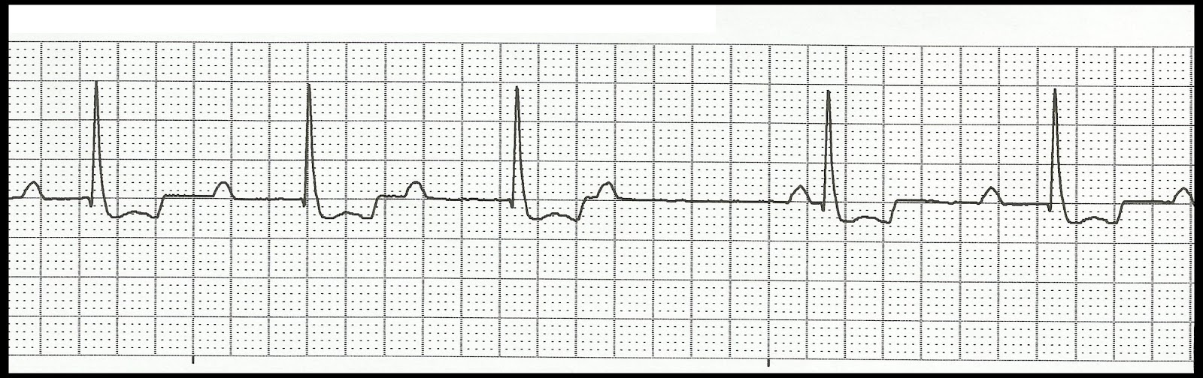

PR: __________ QRS: __________ QT: __________ HR: __________

Interpretation: __________________________________________________________________________________________________________________________________________________________________________

[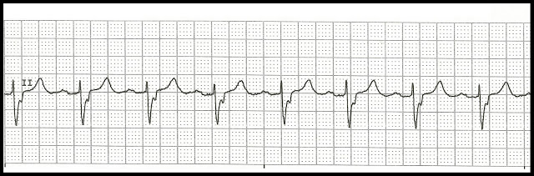](http://4.bp.blogspot.com/-nVLffjBzOM4/UWL-laa4s3I/AAAAAAAASWc/2fnN3ZyZi0E/s1600/1st+degree+block.jpg)

PR: __________ QRS: __________ QT: __________ HR: __________

Interpretation: __________________________________________________________________________________________________________________________________________________________________________

[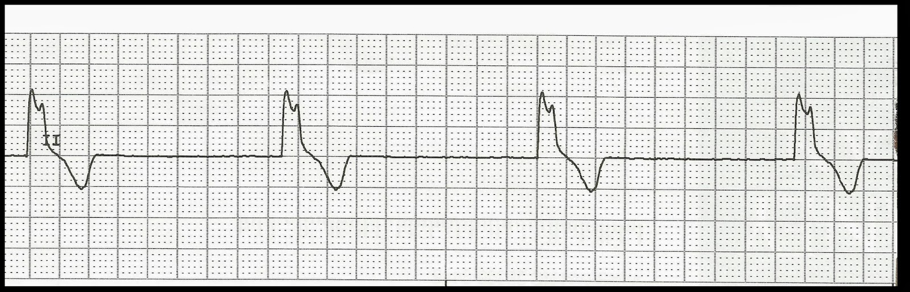](http://1.bp.blogspot.com/-EgGRSf7txAA/UpPWr2O9ULI/AAAAAAAAXDQ/fFNmPt0C9es/s1600/08+Idioventricular+rhythm.jpg)

PR: __________ QRS: __________ QT: __________ HR: __________

Interpretation: __________________________________________________________________________________________________________________________________________________________________________

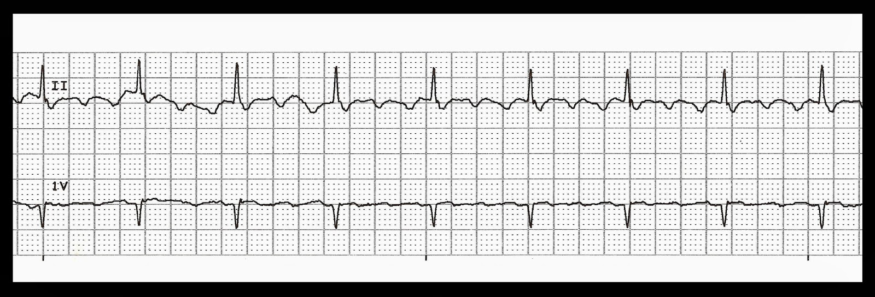

PR: __________ QRS: __________ QT: __________ HR: __________

Interpretation: __________________________________________________________________________________________________________________________________________________________________________

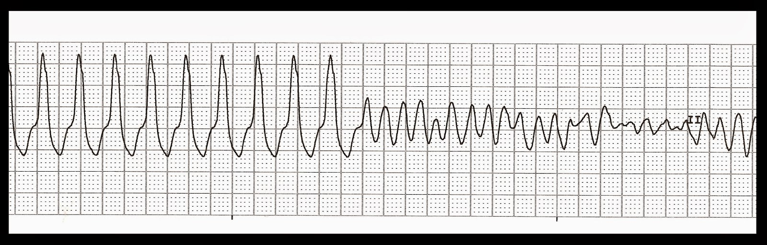

PR: __________ QRS: __________ QT: __________ HR: __________

Interpretation: __________________________________________________________________________________________________________________________________________________________________________

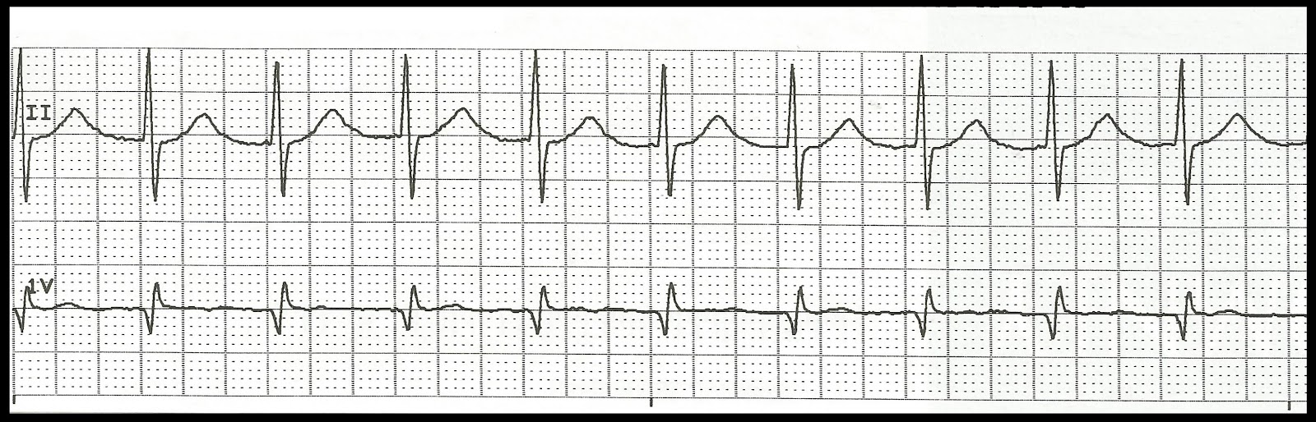

PR: __________ QRS: __________ QT: __________ HR: __________

Interpretation: __________________________________________________________________________________________________________________________________________________________________________

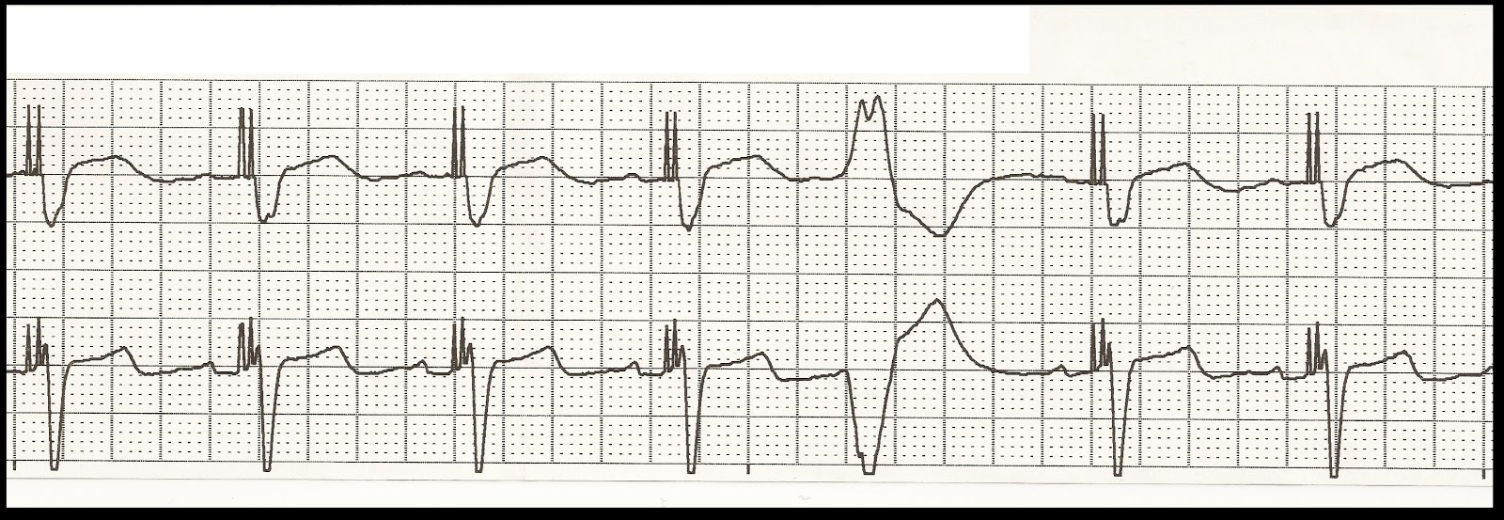

PR: __________ QRS: __________ QT: __________ HR: __________

Interpretation: __________________________________________________________________________________________________________________________________________________________________________

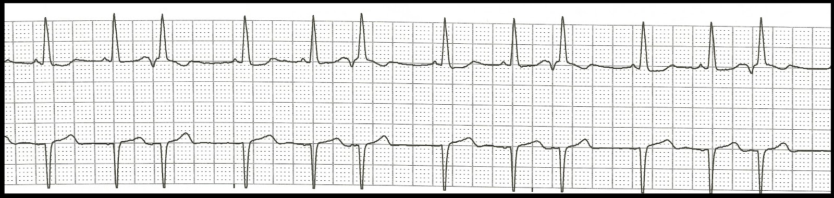

PR: __________ QRS: __________ QT: __________ HR: __________

Interpretation: __________________________________________________________________________________________________________________________________________________________________________

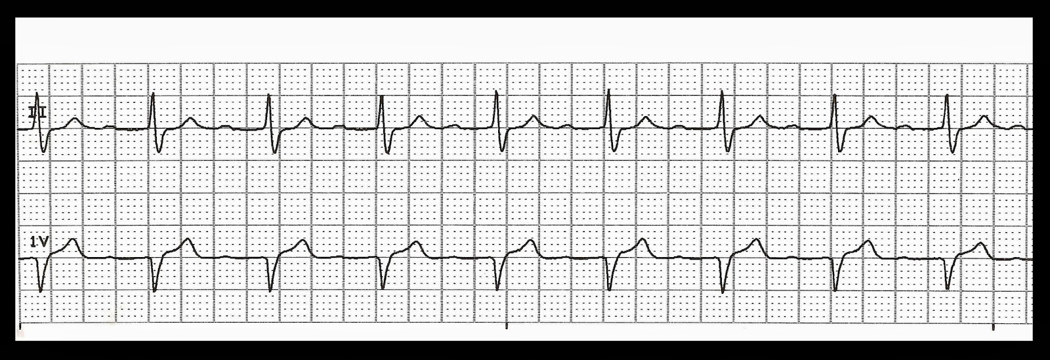

PR: __________ QRS: __________ QT: __________ HR: __________

Interpretation: __________________________________________________________________________________________________________________________________________________________________________

[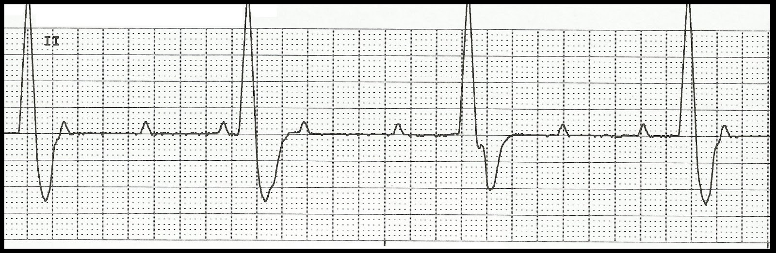](http://2.bp.blogspot.com/-tAEYrVsbQmc/Ues_MujeF4I/AAAAAAAAVYQ/REPuGWv2OGo/s1600/Complete+heart+block+12.jpg)

PR: __________ QRS: __________ QT: __________ HR: __________

Interpretation: __________________________________________________________________________________________________________________________________________________________________________